**A PROJECT REPORT**

**On**

**PERSONAL ASSISTANCE FOR SENIORS WHO ARE SELF-RELIANT**

Submitted By

H. Harisha (Team Lead)-963519106020

K. Arthi -963519106011

R. Anusha-963519106010

M. Shivani-963519106030

***In partial fulfilment for the award of the degree***

***of***

**BACHELOR OF ENGINEERING**

**IN**

                   ELECTRONICS AND COMMUNICATION ENGINEERING

**STELLA MARY’S COLLEGE OF ENGINEERING**

                                             ARUTHENGANVILAI

ANNAUNIVERSITY - CHENNAI 600002

JUNE 2022

# ACKNOWLEDGEMENT

We thank our **GOD ALMIGHTY** who is the source of knowledge and who guided in all aspects to bring out this project a successful one.

We express our hearty gratitude and sincere thanks to the chairman

**Dr. NAZARETHCHARLES, Ex. Indian Navy**, for his encouragement and rendering a platform for completing the project in a successful manner.

We are extremely grateful to **Dr. S. SURESH PREMIL KUMAR, M.E., Ph.D.,** Principal of Stella Mary’s College of Engineering for being a source of inspiration throughout our study.

It’s our solace to thank **Mr. N. Michael Franklin M.E.,** Head of Department of Electronics and Communication Engineering for her continuous encouragement to complete our project.

We extend our sincere thanks to **Mrs. A.B. Evanjalin M.E.,** our Internal guide for her inspiring guidance and valuable advice throughout the completion of our project.

Words are inadequate in offering our thanks to IBM’s **NALAIYA THIRAN**, for a great learning experience and giving us a lot of knowledge on cloud and IT forums.

# TABLE OF CONTENTS

**1. INTRODUCTION**

1.1 Project Overview

1.2 Purpose

**2. LITERATURE SURVEY**

2.1 Existing problem

2.2 References

2.3 Problem Statement Definition

**3. IDEATION & PROPOSED SOLUTION**

3.1 Empathy Map Canvas

3.2 Ideation & Brainstorming

3.3 Proposed Solution

3.4 Problem Solution fit

**4. REQUIREMENT ANALYSIS**

4.1 Functional requirement

4.2 Non-Functional requirements

**5. PROJECT DESIGN**

5.1 Data Flow Diagrams

5.2 Solution & Technical Architecture

5.3 User Stories

**6. PROJECT PLANNING & SCHEDULING**

6.1 Sprint Planning & Estimation

6.2 Sprint Delivery Schedule

**7. IBM CLOUD DELIVERABLES**

8.1 IBM Watson IoT Platform

8.2 Node Red

8.3 Cloudant DB

8.4 Text-to-Speech

8.5 MIT App Inventor

**8. RESULTS**

9.1 Web UI for Medicine Reminder

**9. ADVANTAGES & DISADVANTAGES**

**10. CONCLUSION**

**11. FUTURE SCOPE**

**1.INTRODUCTION**

**1.1 Project overview**

Sometimes elderly people forget to take their medicine at the correct time. They also forget which medicine He / She should take at that particular time. And it is difficult for doctors/ caretakers to monitor the patients around the clock. To avoid this problem, this medicine reminder system is developed. An app is built for the user(caretaker) which enables him to set the desired time and medicine. These details will be stored in the IBM Cloudant DB. If the medicine time arrives the web application will send the medicine name to the IoT Device through the IBM IoT platform. The device will receive the medicine name and notify the user with voice commands.

**1.2 Purpose**

There are many people that uses more than few medicine daily. Our objective is to make it easier for users to remember the medicine that they need to take.

**2. LITERATURE SURVEY**

**2.1 Existing Problem**

To get started with the project, we have analysed various journals and got the information which will leads to the best solution. Existing medicine reminder systems have some disadvantages like high cost, inaccurate and so on. For the effective reminder people are expecting some new features. Voice commands are more interested than text command.

**2.2 References**

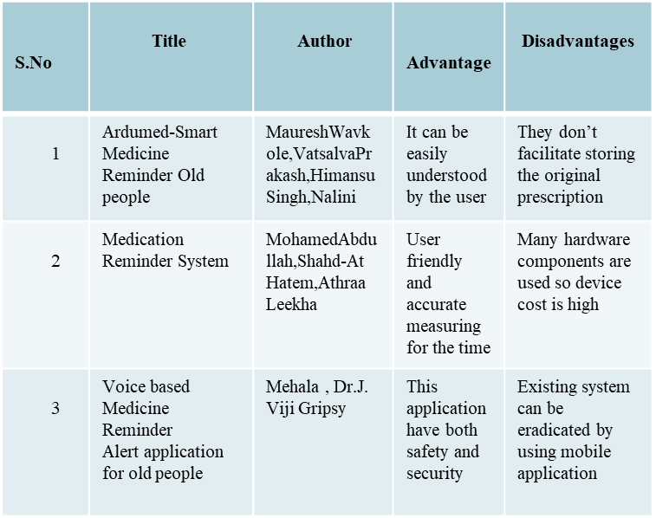

**2.3 Problem Statement Definition**

Some patients and also the caretakers forget to take/give the medicines at the right time. And it is difficult to memory the medicine names. Some people find it difficult to learn new apps in this ever-expanding digital environment, and people nowadays tend to forget things more easily, such as taking their prescriptions. People need a way to remember to take their prescriptions without having to learn how to use sophisticated programs.

**3. IDEATION & PROPOSED SOLUTION**

**3.1 Empathy Map Canvas**

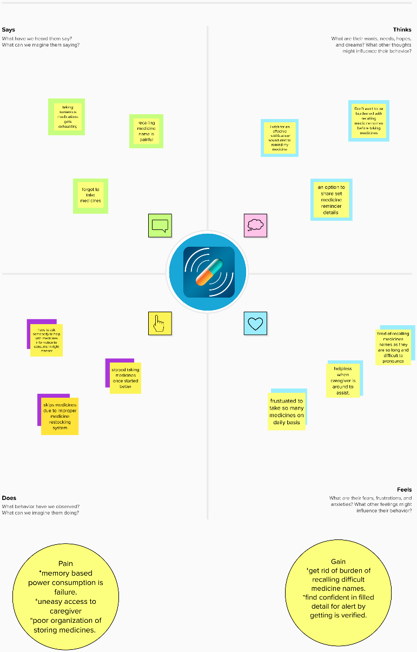

**3.2 Ideation & Brainstorming**

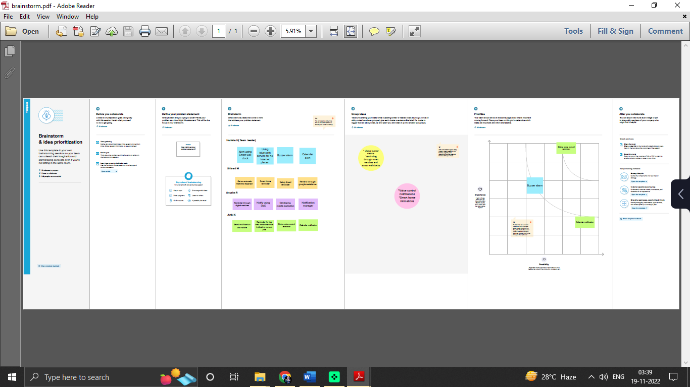

**3.3 Proposed Solution**

|  |  |  |
| --- | --- | --- |
| **S.No.** | **Parameter** | **Description** |
| 1 | Problem Statement | Some patients and also the caretakers forget to take/give the medicines at the right time.And it is difficult to memory the medicine names.Some people find it difficult to learn new apps in this ever-expanding digital environment and people nowadays tend to forget things more easily. Such as taking their prescriptions. People need a way to remember to take their prescriptions without having to learn how to use sophisticated programs. |
| 2 | Idea / Solution description | Make a simple, user-friendly application which helps the patients to remember when to take their medications and what medicine to have. An app is build for the user (caretaker) which enables him to set the desired time and medicine. These details will be stored in the IBM cloudant DB. |
| 3 | Novelty / Uniqueness | In order to better understand the difficulties and expectations people face when remembering daily routines, our team started the research with a set of questions that were addressed to a wide range of people. |
| 4 | Social Impact / Customer Satisfaction | Based on the study results from the user interview, we developed this project.The people will get a remider by a voice message so that they can never feel alone. |
| 5 | Business Model (Revenue Model) | By using the model , we can collect basic and some medical information about the personsal that helps us in showing relevant and profitable advertisements. |
| 6 | Scalability of the Solution | At the model is integrated with cloud software, we can update the user experience without reinstalling a model and the person can keep a reminder up to the year. |

**3.4 Problem Solution fit**

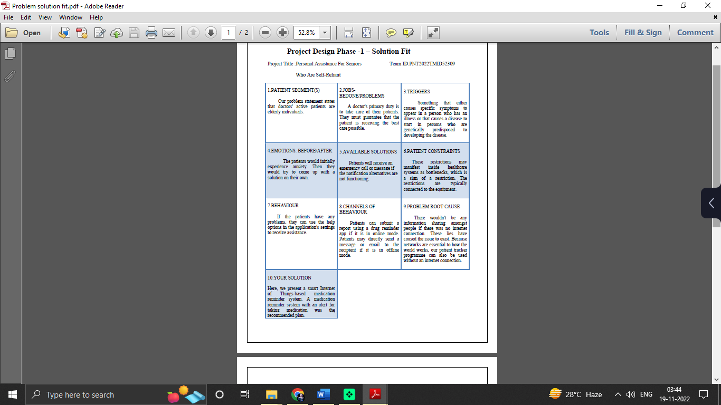

**4. REQUIREMENT ANALYSIS**

**4.1 Functional requirement**

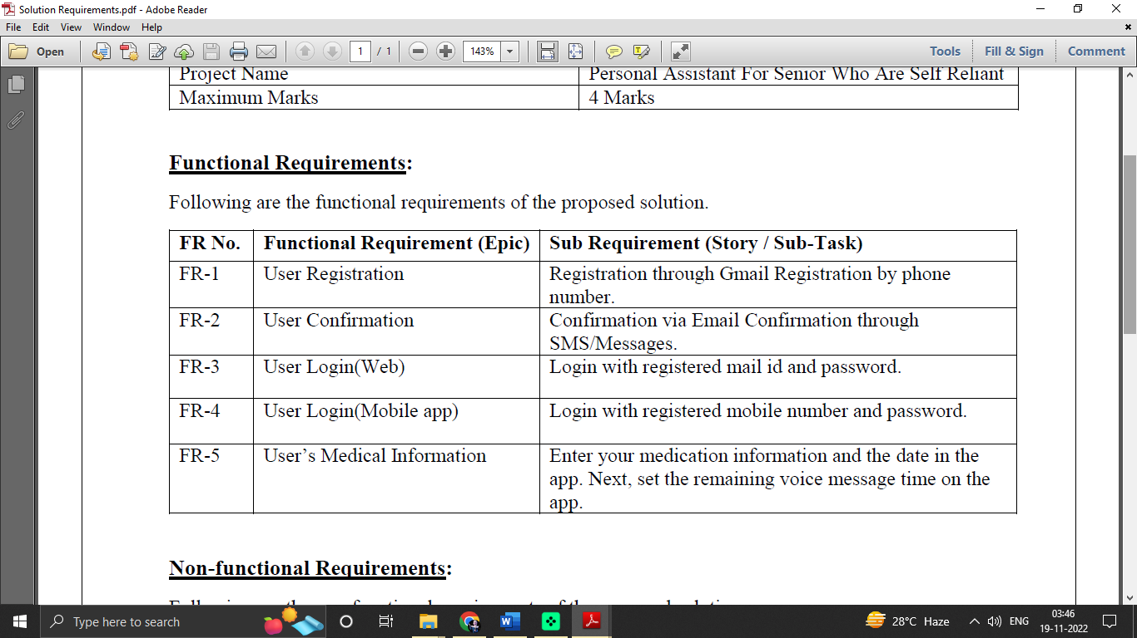

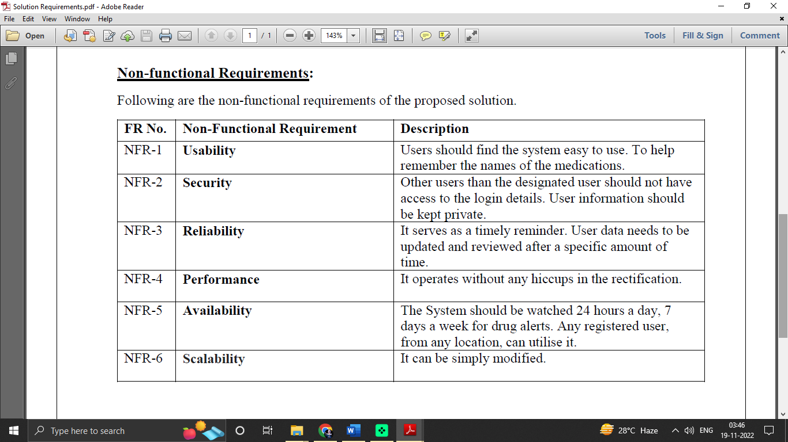

**5. PROJECT DESIGN**

**5.1 Data Flow Diagrams**

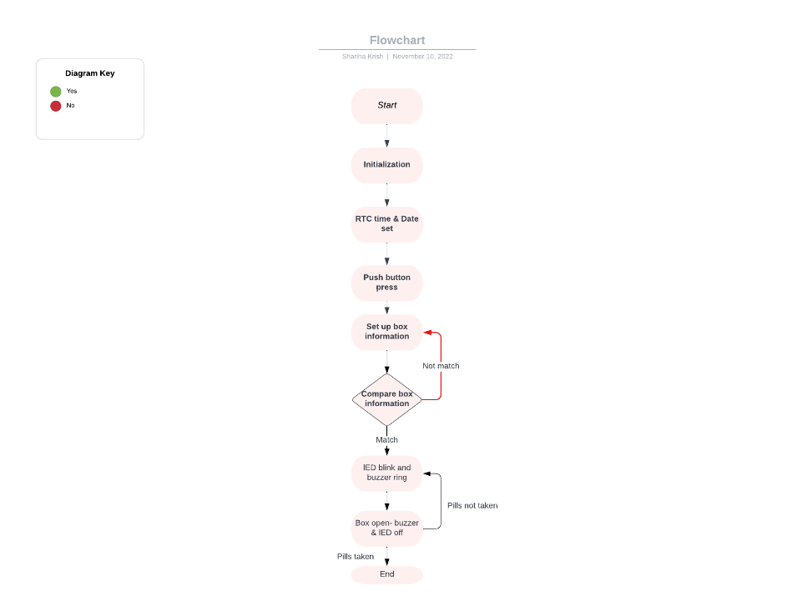

**5.2 Solution & Technical Architecture**

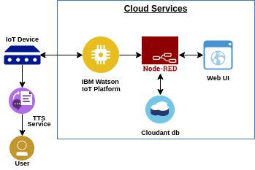

**5.3 User Stories**

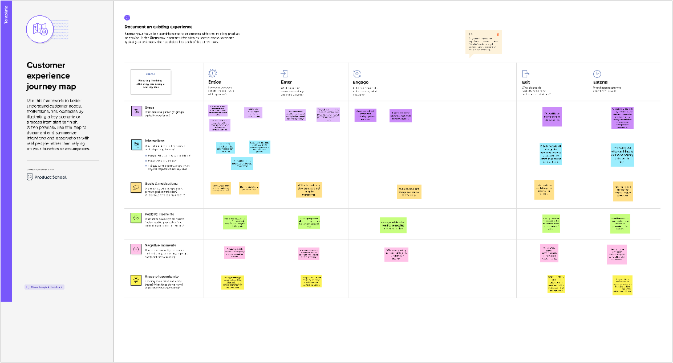

**6. PROJECT PLANNING & SCHEDULING**

**6.1 Sprint Planning & Estimation**

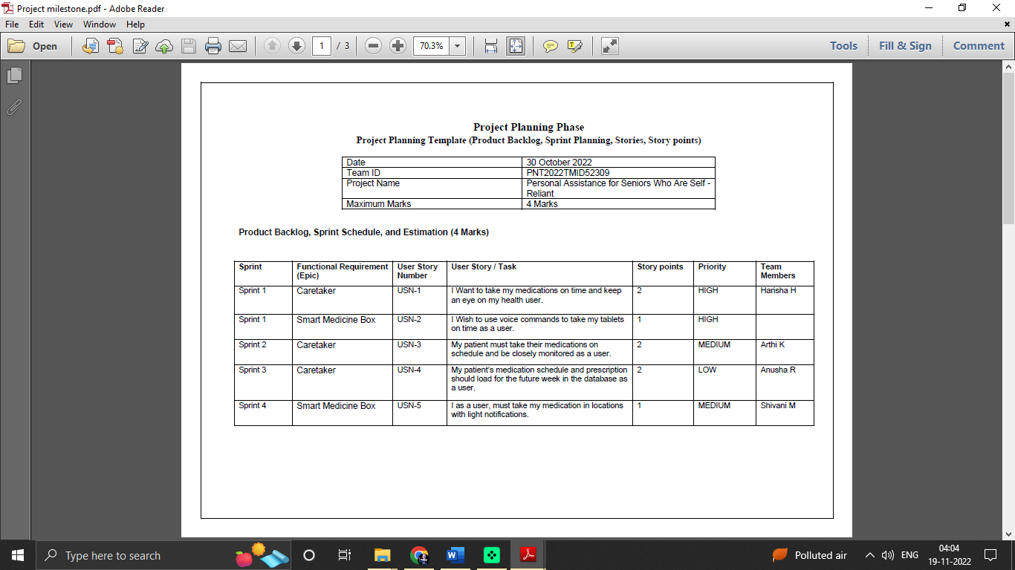

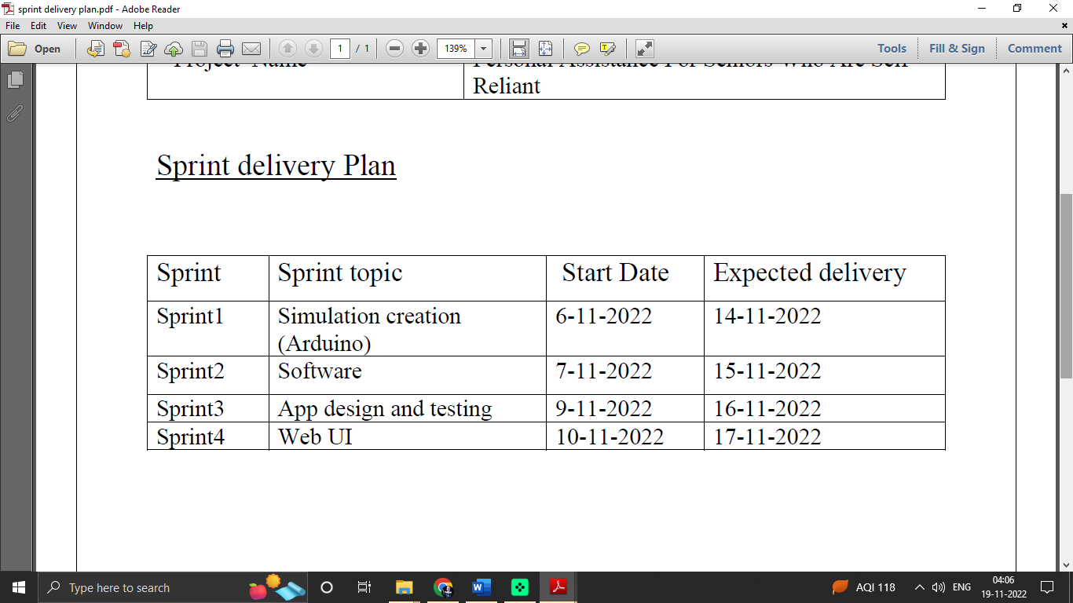**6.2 Sprint Delivery Schedule**

**7.IBM CLOUD DELIVERABLES**

**7.1 IBM Watson IoT Platform**

Creating and launch the IBM Watson IoT platform. In order to connect the IoT device to the IBM cloud, create a device in the IBM Watson IoT platform and get the device credentials. Configure the connection security and create API keys that are used in the Node-RED service for accessing the IBM IoT Platform.

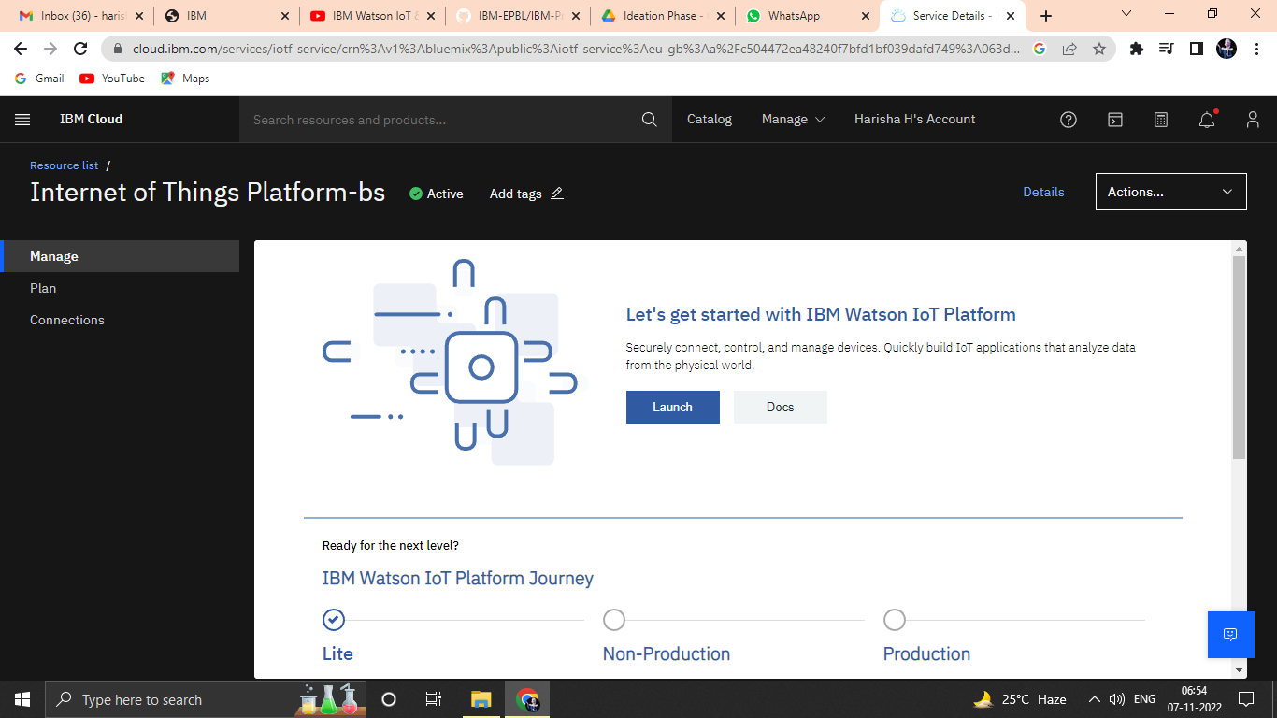

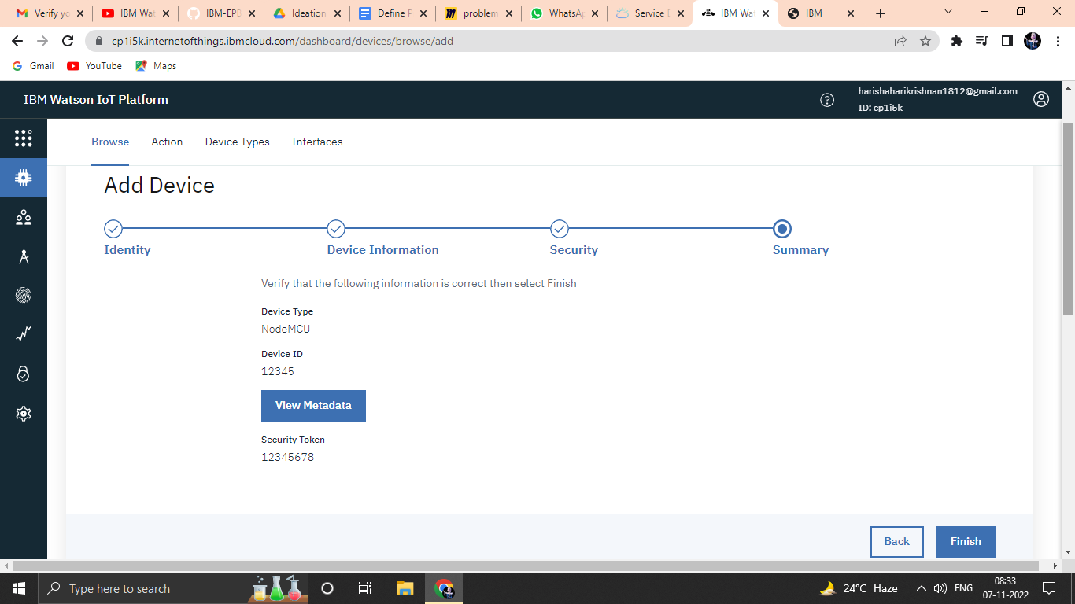

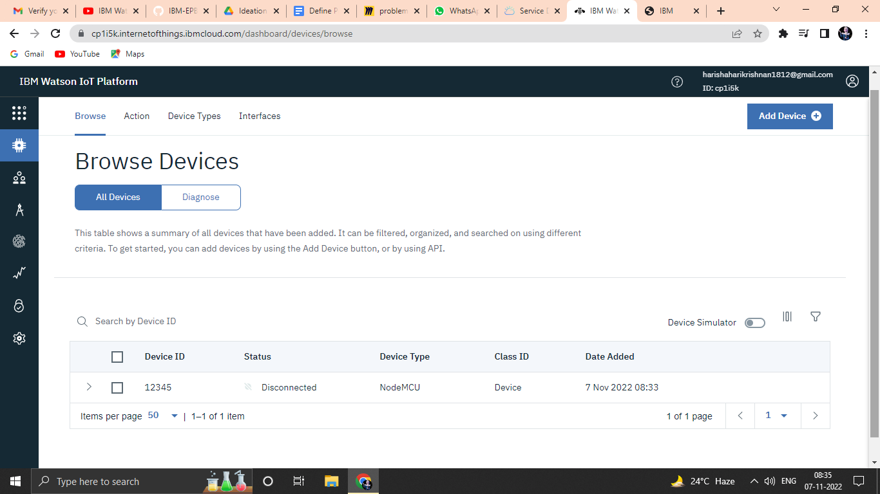

**7.2 Node Red**

To create a web application creating a Node-RED service.

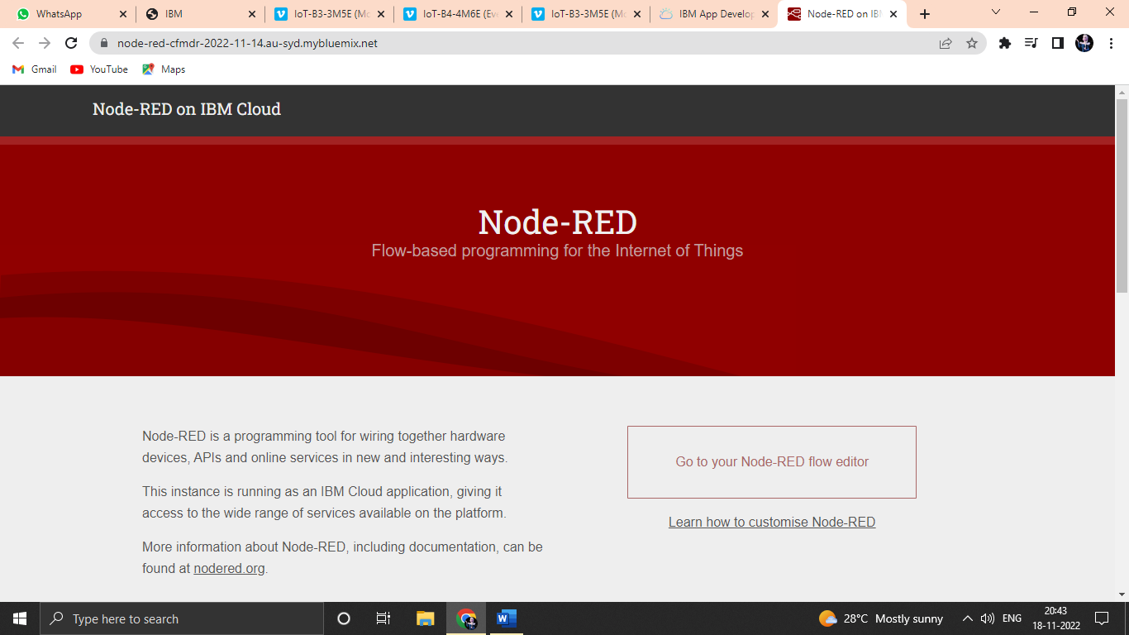

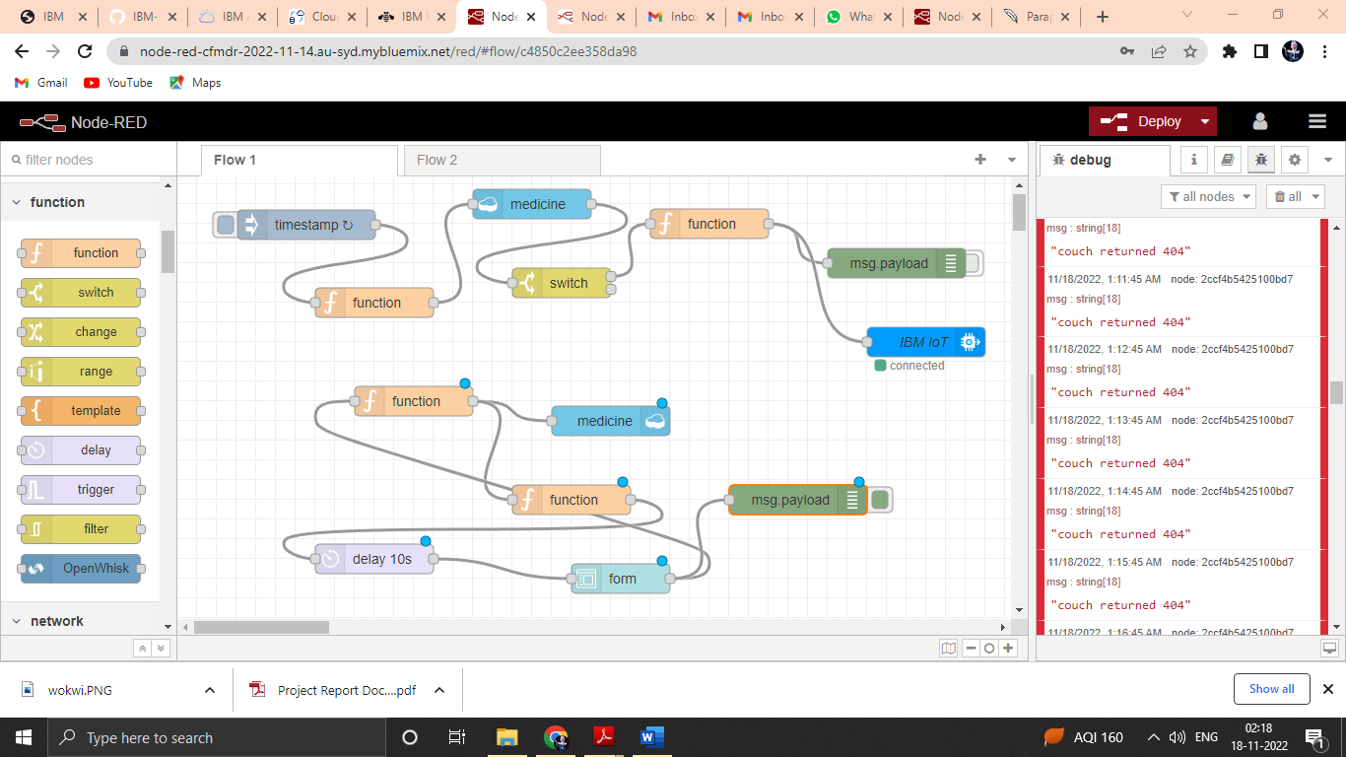

**7.3 Cloudant DB**

Launch the cloudant DB and create a database to store the medicine details.

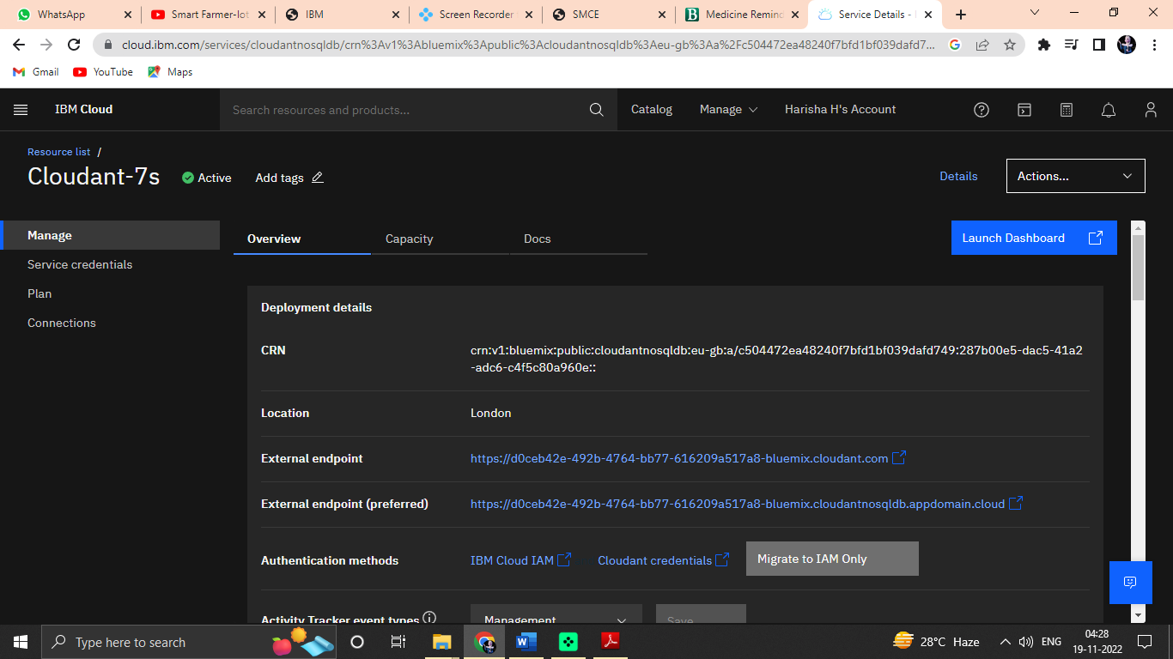

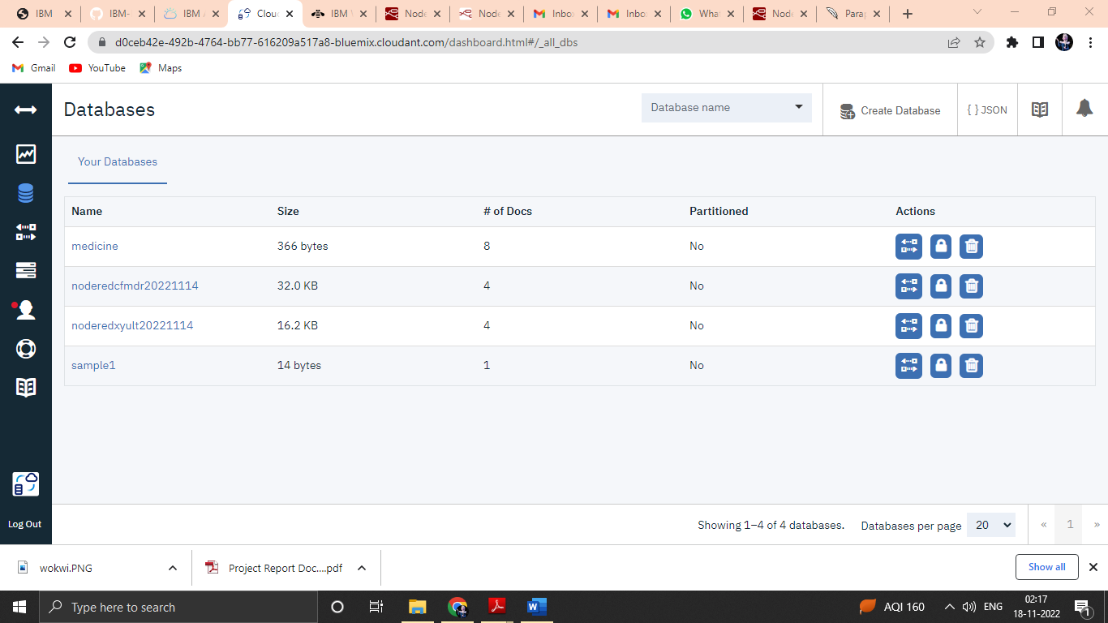

**7.4 Text-to-Speech**

Creating a Text to Speech service to generate the voice commands.



**7.5 MIT App Inventor**

MIT App Inventor is an intuitive, visual programming environment that allows everyone even children to build fully functional apps for smartphones and tablets.

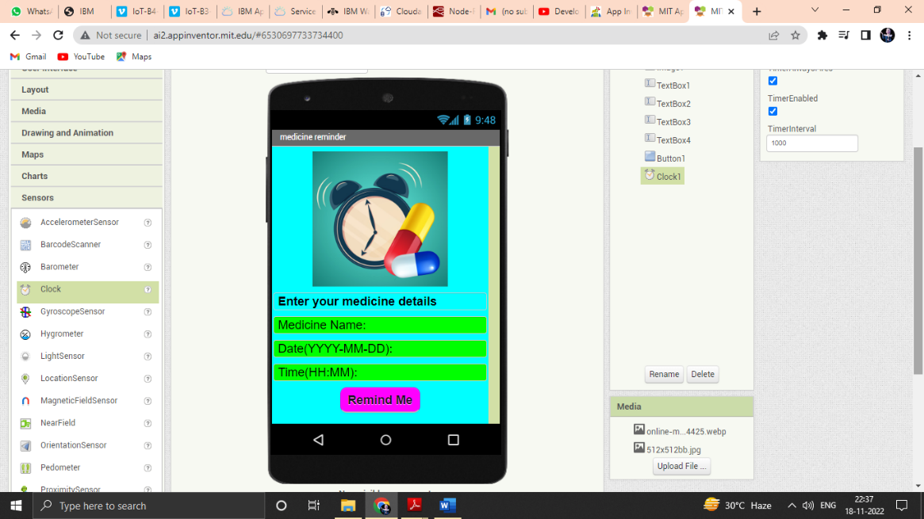

**9.Results**

**9.1 Web UI for Medicine Reminder**

The Web UI, which allows users to interact with the software, is shown in the screenshots that are provided below.

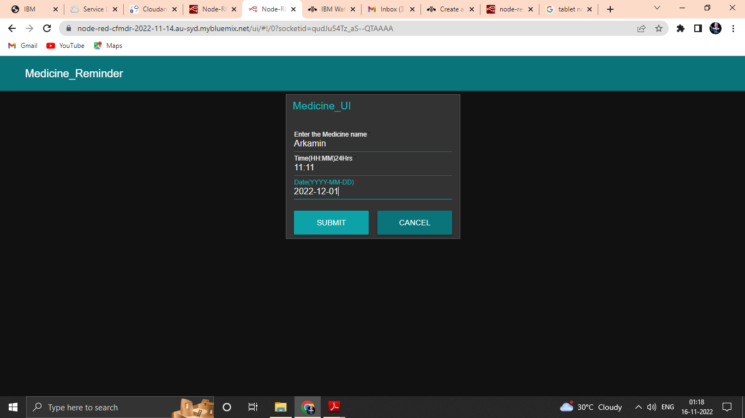

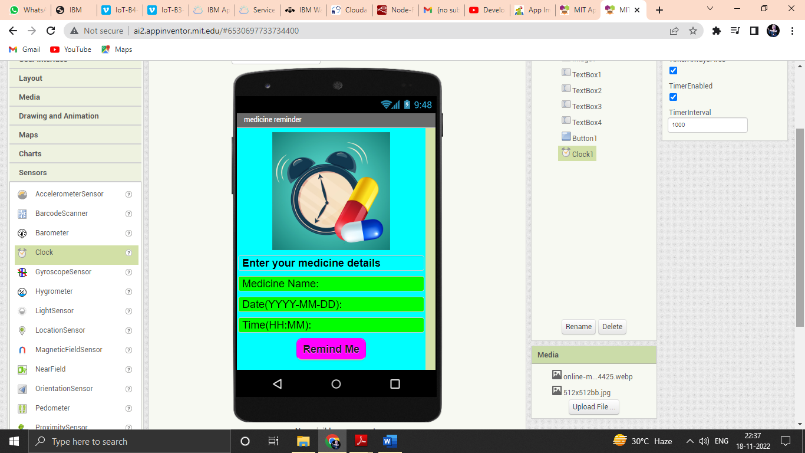

**9. ADVANTAGES & DISADVANTAGES**

9.1 Advantages

The scheduled reminder will not recommend any medication that has not been recommended by a doctor, ensuring the patient's safety and preventing incorrect dosages.

9.2 Disadvantages

Older patients had significantly lower mobile phone ownership rates, making it more difficult to reach them using reminder technologies. Patients could not get the SMS reminders if the data is entered incorrectly.

**10. CONCLUSION**

The Medicine Reminder will be very helpful to many patients. It helps to take proper medicine at right time. The cost of production is low as compared to other problem solutions. We intend to concentrate on enhancing the system's overall performance. Additionally, attention will be paid to interactions between patients and doctors via secure prescriptions. We'll concentrate on a few more strategies for improving drug adherence.

**11. FUTURE SCOPE**

The services assist customers in properly comprehending the system so that it can be beneficial and fruitfull. Reminders for taking medications aid in reducing drug mistakes and incorrect dosages.

GitHub link: https://github.com/IBM-EPBL/IBM-Project-49761-1660838094

Demo link: https://youtu.be/4fgG8XciN9k